The Wizard’s Temple
Assignment 2
CIS002-3

Zak Rogers
1708629
Table of Contents
Introduction 2
Pitch Document 2
Vision 2
Features 2
Player Motivation 2
Genre 2
Target Customer 2
Competition 2
The Talos Principle – 2
The Turing Test – 2
Platforms 3
Design goals 3
Further details 3
Spells: 3
Obstacles: 3
Ending challenge: 3
Development plan 4
Tasks 4
Models 4
Animations: 4
Programming: 4
Particles: 5
Build levels: 5
UI: 5
Audio: 5
Class Diagram 6
Iterations 7
Test plan 8
Gantt Chart 10
Self-Reflection 11
References 13
Bibliography 16
Appendix 17

Introduction

For this assignment, I will be creating a new 3D puzzle game with Unity (2020) to upload to Itch.io (2021). The game will be called “The Wizard’s Temple” and will be about a wizard exploring an ancient temple in search of a legendary staff. This report contains the pitch document for the game along with a development plan, testing plan and a self-evaluation of the project.

Pitch Document

Vision
You are a wizard exploring an ancient ruin in search of a legendary staff, what challenges could await?

Features
- Variety of Spells – the wizard will learn new spells on his adventure which will help him overcome a variety of puzzle-based challenges.
- Xbox Controller support
- 3rd person view and camera can be turned left and right.

Player Motivation
The player will progress through levels, heading deeper into the ruins, by completing unique challenges using spells learnt along the way.

Genre
3D Puzzle Game

Target Customer
Players of all ages that enjoy puzzle games and are into a fantasy genre.

Competition

The Talos Principle –
The Talos Principle (Croteam, 2014) is a first-person puzzle game where you use equipment such as jammers to overcome obstacles like electric barricades.

The Turing Test –
The Turning Test (Bulkhead Interactive, 2016) is another first-person puzzle game where you use a device to move a power source around to power objects such as doors and electromagnets.

Platforms
PC

Design goals
Problem-solving: players will have to learn what the spells can do and use this knowledge to solve puzzle challenges.
Simple Controls: both keyboard and controller button layout will be natural, such as jumping using the “Space” or “A” button which is very common.

Further details

Spells:
Ice spell – Freezes water allowing the player to cross.
Levitate – allows the player to hover for a short period of time.
Telekinesis – allow the player to interact a heavy or out of reach object.
Staff- the staff the player finds at the end will allow the player to destroy blocks to escape.

Obstacles:
Water – will reset the player on contact, unless it becomes frozen then the player can slide on it.
Lava – will reset the player.
Some objects will be able to be affected by telekinesis – either by moving to a set position or triggering something such as a lever or pushing an object.

Ending challenge:
Once the player reaches the staff, they must escape using the new power given by the staff to destroy blocks and using other spells to overcome challenges.

Development plan

For this project, I will be following an iterative model for project management. Below I will write several tables with the tasks which will be needed to complete the project along with an estimated duration of the task. Then I will create a class diagram for the project and finally group the tasks into suitable iterations of the project.
Tasks:
Models:
Task | Estimated Duration
Wizard + Rig | 3 Hours
Lectern | 1 Hour
Book + Rig | 1 Hour
Staff | 1 Hour
Source environment models | 2 Hours

Animations:
Task | Estimated Duration
Wizard - Idle | 2 Hours
Wizard - Walk | 2 Hours
Wizard - Sliding | 2 Hours
Wizard – Cast Spell | 1 Hour
Book- Open | 1 Hour

Programming:
Task | Estimated Duration
Movement | 2 Hours
Camera Movement | 2 Hours
Water Object | 2 Hours
Lava Object | 1 Hour
Spell Event System | 2 Hours
Ice Spell | 1 Hour
Levitate | 1 Hour
Telekinesis Spell | 2 Hours
Telekinesis Object | 1 Hour
Staff Destruction Spell | 1 Hour
Destructible Object | 2 Hours
Main Menu | 1 Hour
Level Exit | 30 Minutes
Book | 30 Minutes

Particles:

Task | Estimated Duration
Ice Spell | 1 Hour
Levitate Spell | 1 Hour
Telekinesis Spell | 1 Hour
Staff Spell | 1 Hour

Build levels:

Task | Estimated Duration
Level 1 | 4 Hours
Level 2 | 4 Hours
Level 3 | 4 Hours
Level 4 | 6 Hours

UI:

Task | Estimated Duration
Main Menu | 1 Hour
Controls Menu | 1 Hour
Settings Menu | 1 Hour
Victory Menu | 1 Hour

Audio:

Task | Estimated Duration
Source Audio - Walk | 10 Minutes
Source Audio - Jump | 10 Minutes
Source Audio – Ice Spell | 10 Minutes
Source Audio – Levitate Spell | 10 Minutes
Source Audio – Telekinesis Spell | 10 Minutes
Source Audio – Staff Spell | 10 Minutes
Source Audio – Book Opening | 10 Minutes
Source Audio – Page Turning | 10 Minutes
Source Audio – Learn New Spell | 10 Minutes
Source Audio – Found Staff | 10 Minutes
Background Music – Level 1 | 10 Minutes
Background Music – Level 2 | 10 Minutes
Background Music – Level 3 | 10 Minutes
Background Music – Level 4 | 10 Minutes
Ambient Sound - Ice | 10 Minutes
Ambient Sound – Lava | 10 Minutes
Ambient Sound – Cavern Sound Effects | 10 Minutes
Implement Audio | 1 Hour

Class Diagram
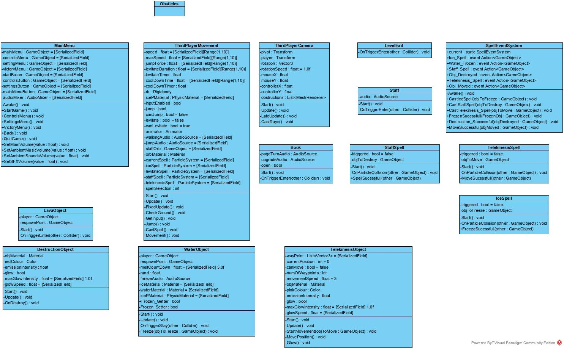

Iterations

Version | Description | Estimated Duration
1 | Model wizard, Implement player and camera controls. | 8 Hours
2 | Animate wizard, Implement Water and Lava obstacles. | 9 Hours
3 | Implement Ice Spell, levitate spell and model book and lectern. write book class and spell event system. | 7 Hours
4 | Model staff, implement telekinesis and the staff’s destruction spell and their respective object classes. | 9 Hours
5 | Create particle systems, animate book, source and implement audio. | 8 Hours
6 | Source environment models, create the first level. | 6 Hours
7 | Create 2nd and 3rd levels. | 8 Hours
8 | Create the final level and menus. | 7 Hours
9 | Add post-processing and Add detailing props to levels. | 4 Hours
10 | Built game | 1 Hour

Test plan

Version | Testing Tasks | Test Successful? | Notes | Further Steps
1 | Check all inputs work.  - Walk  - Jump  - cast spell | ☒ | Debug logs displayed to show keyboard and controller inputs were working. During testing, I adjusted variables in the inspector to better tune the movement. | N/A
2 | Check each animation plays and exit correctly.  - Walk and fall have no exit time.  - Jump and attack do have exit time on exit transition. | ☒ | Animations enter and exit correctly with idle and walking looping | N/A
3 | - Test that book gives the player a spell.  - the player can cast it.  - Check water freezes and returns to water. | ☐ | The player slides and plays animation but is still controllable which does feel right. Levitation is a lot high than expected due to no gravity. | Add a way for input to be disabled when the player Is sliding. Adjust levitation hight to account for lack of gravity.
4 | Check spells and objects work as expected. | ☒ | No issues | N/A
5 | - Check all audio plays at the right time.  - Each particle system plays when the correct spell is cast.  - Confirm book animates to open when the player approaches. | ☐ | Book replays open animation and audio if the player walks near to the lectern after getting a spell. | Add a bool for if the book is open and only play if it is not.
6 | Play through 1st level check there are no issues with the 3rd part assets and the level can be completed. | ☐ | A couple of books were floating, the mud pile had a collider which could cause issues with the player's movement and if the player jumped onto the crates they could not jump again. | - Adjust the objects that are floating.  - Remove collider from the mud.  - Set items which will be jumped onto suck as rocks, crates and platforms to the ground tag.
7 | Check levels can be completed. | ☒ | No Issues | N/A
8 | Check navigation between each menu, play Final level | ☐ | Menu navigation works fine. Final level playable however I managed to get stuck in a spot. | Remove or adjust pillar which can cause the player to get stuck.
9 | Play through the full game. | ☒ | Played through twice once with controller and the other with keyboard and mouse. No issues noticed. | N/A

Gantt Chart
Testing
Development

Self-Reflection

I started my assignment, in predevelopment, I created a pitch document detailing the different features and theme of the game, then listed all the tasks I could think of that would be needed to be completed to accomplish the game. Using the lists, I created a class diagram, using Visual Paradigm (2021), that I will be needing and set about grouping the tasks into different iterations of the game. This will make it easier to test after each iteration and adjust my development plan if needed to add anything overlooked or fixes to bugs encountered. I then created a testing plan for each stage. Finally, I added my list of versions into Excel (Microsoft, 2021) and then, having worked out how many hours I can work on the game each day, I worked out a start and end date for each task and generated a GANNT chart.
The first iteration was to have the character model with control input and camera controls. I started by modelling the wizard [Fig. 1] in Maya (Autodesk, 2018) and exporting it as an fbx file to import into my unity project. From there I wrote the player controller script which takes input from the vertical and horizontal axis and moves a rigid body by using the Add Force method. Taking influence from other 3d games such as Lego Harry Potter (TT Games, 2010) I made the character move forward and backwards relative to the camera and strafe side to side relative to the player.
Initially, for the camera I added a single ray cast to see if there was any obstacle in between the player and the camera and if so, disable the mesh render, this was so if the player moved the camera through the wall in the level, they would still be able to see what they are doing. I later increased the number of rays as I found that the ray would occasion hit a pillar only making the pillar see-through and not the walls so you still could not see the character, you would also only have a small section to see through when It hid a wall [Fig. 2,3] I also added a new layer for camera obstructions and added the walls and pillars to the layer. Finally, I added a layer mask to the Raycast so it would only collider with game objects on the camera obstructions layer.
During the second iteration, I created a skeleton for the wizard along with IK handles and controllers [Fig 4], to aid in the animation, and proceeded to create each animation. When they were completed, I baked the animations and exported the model again but including baked animations. Once in Unity, I reimported the wizard character and separating each on the animation clips, in the animation tab of the import settings [Fig.5] and looping the animations that needed to loop. This took a little longer than estimated due to a couple of issues which required me to redo my rig fortunately I paired it with two other task which did not take long.
For the spells in the third version, I decided to implement the levitation spell, through the character controller, by removing gravity from the rigid body and at first setting the position of the player to the start position add the jump force however I found that with gravity removed the player moves too high [Fig. 6], so I divided it by 10. For the ice spell, I started by casting a ray Infront of the player to see if it hit an object that has the water tag. Later after adding the particle systems for the spells’ I added collision to them to detect what object they collide with.
Then I set up an event system, as to not break encapsulation, which the spells could trigger an event to affect objects which have subscribed to each event. I needed to do a little research into creating an event system and came across a useful video (Game Dev Guide, 2019) with this information I created an event system which had an event Action for the ice spell which would pass in the game object the spell collided with. The subscribed game objects then check whether it was itself that was hit, using the parameter and if so freezes.
For modelling the staff, I opened the wizard Maya file and created it separately in there then using a locator I was able to reexport the model with the staff and the staff separately. Because of the locator, the staff would follow the hand in all the animations [Fig. 7] meaning no new animations would be needed, I then set the wizard’s child object, the staff, to disabled to later be enabled when the player finds the staff.
After creating the particle systems for the spells, I initially found that the event was being triggered multiple time because each particle had a collider which triggered the event, to get around this I added a bool to the spell script to check if it had been triggered and if so, no longer call the event unless it was no longer triggered. This meant that I had to add another event to confirm the water had frozen. Next, I sourced my audio from Freedsound (2021) and implemented them into the necessary scripts. I created a new audio mixer which all the sound sources played too and added a group for the main music, ambient sounds and sound effects [Fig. 8].
Next, I sourced 3rd party assets through the Unity asset store (Unity, 2021) and imported them into unity. Using the floor and wall assets from the Stylized Hand Painted Dungeon pack (L2S ARTS, 2020), having set them to static game objects with the floor having the ground tag, I built my first level, which will be the level that introduces the player to the ice spell. Using the Modular Medieval Lanterns pack (A. Voevodov, 2018), which I added point lights to, added lighting to the level [Fig.9]. I also set the ambient colour for the environment lighting, within the lighting window, to a light grey [Fig. 10].
Using the same process as for making the first level I did the same for the 2nd, which introduces the levitation spell, and the 3rd that introduces the telekinesis spell. The last level I wanted to make as an example of a level after you have gotten the staff, to give the player a level in which they must use multiple spells to escape. Then I created a new scene where I built a small room to act as a backdrop for the menus. To create the menus, I added a canvas for each menu to the scene and added the required buttons to the canvas. Finally, I wrote the main menu script which Included methods for each button, which also set the selected game object depending on what menu was opening, to allow controller support within the menus. It also contained methods to set the volume for separate groups in the audio mixer for the settings menu.
To finish off the game I added some global postprocessing effects such as depth of field, bloom, colour adjustments and vignette [Fig. 11]. I also went through each level adding more detailing props such as mud, tables, cauldron to make the levels look less empty. Finally, I built the game and tested it thoroughly with both controller and keyboard and mouse.
Overall, I believe the project went well with only a slight run over from the estimated completion date and included everything I wanted to from the plan. Using an iterative project management model meant I was able to work on a section then test it and go back to add or change things later.

References

Unity (2020) Unity (20.1.6f1) [Computer program].
Available at: https://unity.com/ (Accessed: 8/12/20)

Itch.io (2021) Download the latest indie games - itch.io.
Available at: https://itch.io (Accessed: 8/1/21)

Croteam (2014) The Talos Principle. Devolver Digital
Available at: https://store.steampowered.com/app/257510/The_Talos_Principle/?curator_clanid=26165323 (Accessed: 8/1/21)

Bulkhead Interactive (2016) The Turing Test. Square Enix
Available at: https://store.steampowered.com/app/499520/The_Turing_Test/?curator_clanid=26165323 (Accessed: 8/1/21)

Visual Paradigm (2021) Visual Paradigm (16.2) [Computer program].
Available at: https://www.visual-paradigm.com/ (Accessed: 8/1/21)

Microsoft (2021) Excel (Microsoft 365) [Computer program].
Available at: https://www.microsoft.com/en-gb/microsoft-365/excel (Accessed: 8/1/21)

Autodesk (2018) Maya (2018) [Computer program].
Available at: https://www.autodesk.co.uk/products/maya/overview?plc=MAYA&term=1-YEAR&support=ADVANCED&quantity=1 (Accessed: 8/1/21)

TT Games (2010) Lego Harry Potter: Years 1-4. Warner Bros. Interactive Entertainment
Available at: https://store.steampowered.com/app/21130/LEGO_Harry_Potter_Years_14/ (Accessed: 8/1/21)

Game Dev Guide (2019) How To Build An Event System in Unity (6/5/19)
Available at: https://www.youtube.com/watch?v=gx0Lt4tCDE0&t=386s (Accessed: 8/1/21)

Freesound (2021) Freesound -Freesound.
Available at: https://freesound.org/ (Accessed: 8/1/21)

Yudena (2017) Magic_byMondfisch89.ogg.
Available at: https://freesound.org/people/Yudena/sounds/377600/ (Accessed 8/1/21)

Robinhood76 (2016) 06741 good news magic ding.wav.
Available at: https://freesound.org/people/Robinhood76/sounds/350352/(Accessed 8/1/21)

Bastianhallo (2018) Magic.mp3.
Available at: https://freesound.org/people/Bastianhallo/sounds/434050/ (Accessed 8/1/21)

alanmcki (2017) Magic portal open.
Available at: https://freesound.org/people/alanmcki/sounds/401324/ (Accessed 8/1/21)

qubodup (2014) Space Magic.
Available at: https://freesound.org/people/qubodup/sounds/238996/ (Accessed 8/1/21)

qubodup (2018) Magic Spell.
Available at: https://freesound.org/people/qubodup/sounds/442774/ (Accessed 8/1/21)

JennaW_ksc (2020) Sound Walk – Walking.wav.
Available at: https://freesound.org/people/JennaW_ksc/sounds/537719/ (Accessed 8/1/21)

BehanSean (2018) Jumps start.wav.
Available at: https://freesound.org/people/BehanSean/sounds/422426/ (Accessed 8/1/21)

MATRIXXX_ (2017) Page_Turn02.wav.
Available at: https://freesound.org/people/MATRIXXX_/sounds/397549/ (Accessed 8/1/21)
RoivasUGO (2014) Messing around with a book.
Available at: https://freesound.org/people/RoivasUGO/sounds/231460/ (Accessed 8/1/21)

GergorQuendel (2018) Ice – Effects – Sequences 02.
Available at: https://freesound.org/people/GregorQuendel/sounds/424993/ (Accessed 8/1/21)

Fission9 (2019) Lava Loop 3.
Available at: https://freesound.org/people/Fission9/sounds/474851/ (Accessed 8/1/21)

SolarPhasing (2019) Dark Background Cave 1.wav.
Available at: https://freesound.org/people/SolarPhasing/sounds/490584/ (Accessed 8/1/21)

Magmi.Soundtracks (2020) Emotional Original Soundtrack – NO HOPE.
Available at: https://freesound.org/people/Magmi.Soundtracks/sounds/510750/ (Accessed 8/1/21)

X3nus (2020) Magical Travel.flac.
Available at: https://freesound.org/people/X3nus/sounds/509679/ (Accessed 8/1/21)

deleted_user_4397472 (2018) Fantasy Loop.
Available at: https://freesound.org/people/deleted_user_4397472/sounds/447128/ (Accessed 8/1/21)

groovy_blue (2019) Army Return.
Available at: https://freesound.org/people/groovy_blue/sounds/494748/ (Accessed 8/1/21)

taren1965 (2011) Celebration Theme.aif.
Available at: https://freesound.org/people/taren1965/sounds/132480/ (Accessed 8/1/21)

Unity (2020) Unity asset Store – The Best Assets for Game Making.
Available at: https://assetstore.unity.com/ (Accessed 8/1/21)

L2S ARTS (2020) Stylized Hand Painted Dungeon (Free) [3D Model]
Available at: https://assetstore.unity.com/packages/3d/environments/stylized-hand-painted-dungeon-free-173934 (Accessed 8/1/21)

Alexandr Voevodov (2018) Modular Medieval Lanterns [3D Model]
Available at: https://assetstore.unity.com/packages/3d/environments/historic/modular-medieval-lanterns-85527 (Accessed 8/1/21)

Ioan Stan (2018) Altar Ruins Free [3D Model]
Available at: https://assetstore.unity.com/packages/3d/environments/fantasy/altar-ruins-free-109065 (Accessed 8/1/21)

JustCreate (2020) Low Poly Dungeons Lite [3D Model]
Available at: https://assetstore.unity.com/packages/3d/environments/dungeons/low-poly-dungeons-lite-177937 (Accessed 8/1/2021)

Cumberland Fontworks (2021) Cup and Talon Font [Font]
Available at: https://www.1001fonts.com/cup-and-talon-font.html (Accessed 8/1/21)

Bibliography

Cujo Sound (2019) Unity and Wwise - Raycasting with Layermasks (8/1/19)
Available at: https://www.youtube.com/watch?v=WpQOBsxFciE (Accessed 8/1/21)

GameDev.tv (2017) 8 Raycasting and Layer Masks (14/3/17)
Available at: https://www.youtube.com/watch?v=oFoDZvUdfq0 (Accessed 8/1/21)

Unity (2021) Unity – scripting API: Physics.Raycast.
Available at: https://docs.unity3d.com/ScriptReference/Physics.Raycast.html (Accessed 8/1/21)

Academic Phoenix Plus (2019) Intro to Rigging in Maya 2019 (5/6/19)
Available at: https://www.youtube.com/watch?v=1wvdQy2Fdhw (Accessed 8/1/21)

Mr. H (2014) Animating A Character Throwing a Ball in Autodesk Maya 2014 (6/2/14)
Available at: https://www.youtube.com/watch?v=XII9aKbVXrg&t=667s (Accessed 8/1/21)

Appendix

Fig. 1
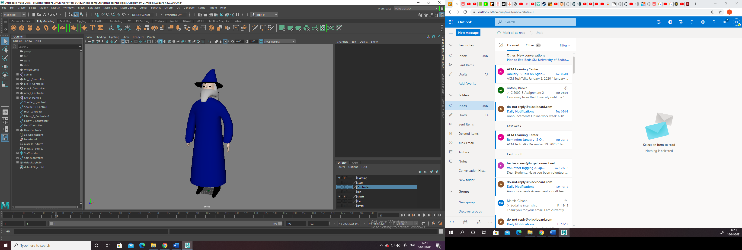
Fig. 2
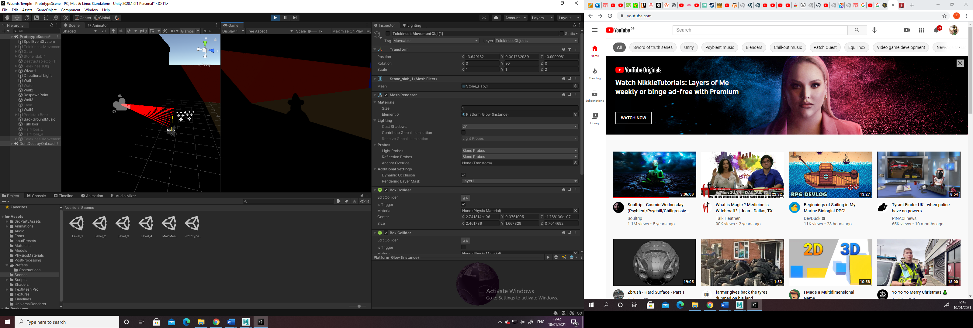

Fig. 3
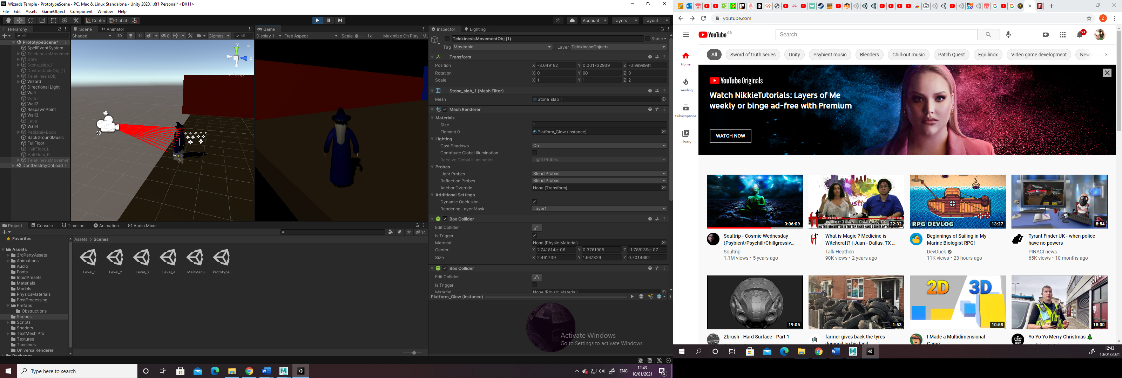

Fig. 4
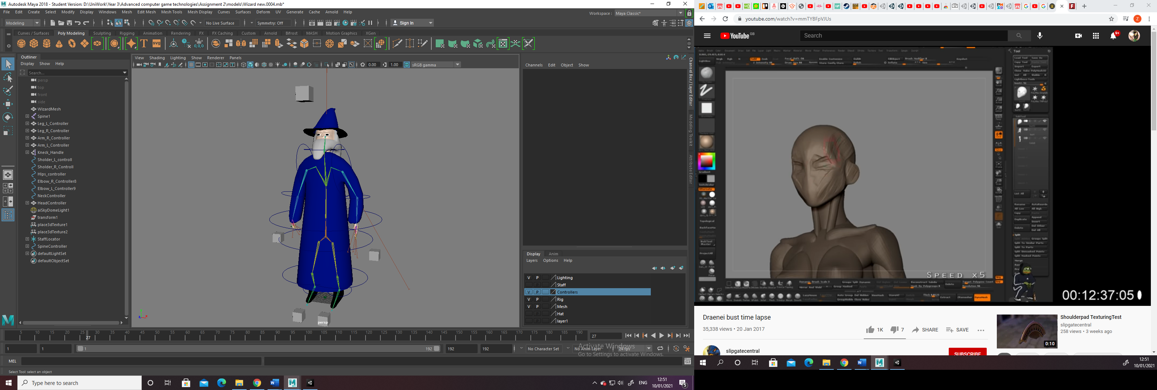

Fig.5
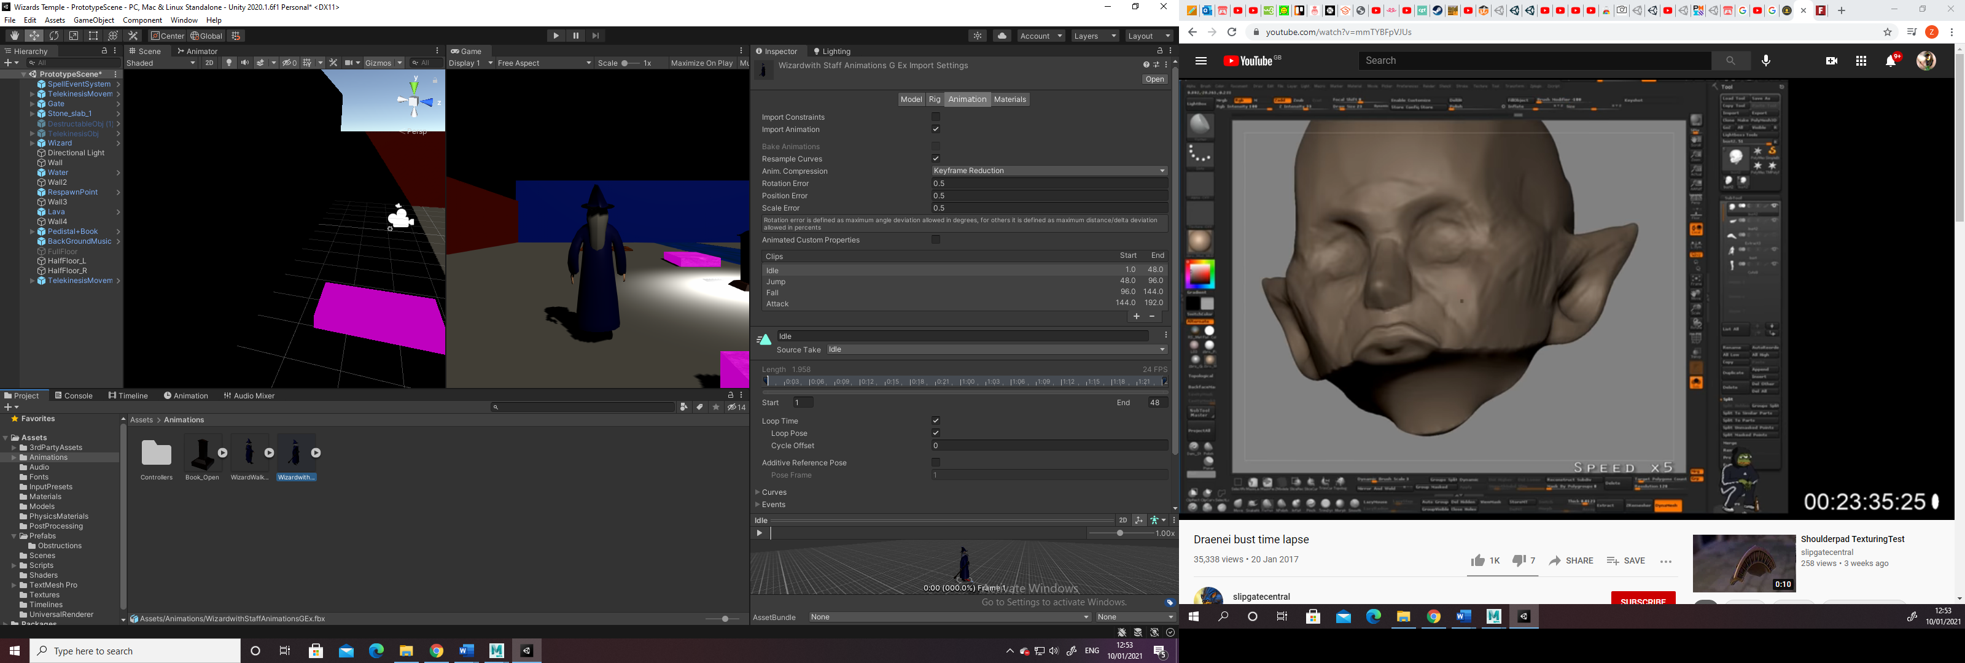

Fig. 6
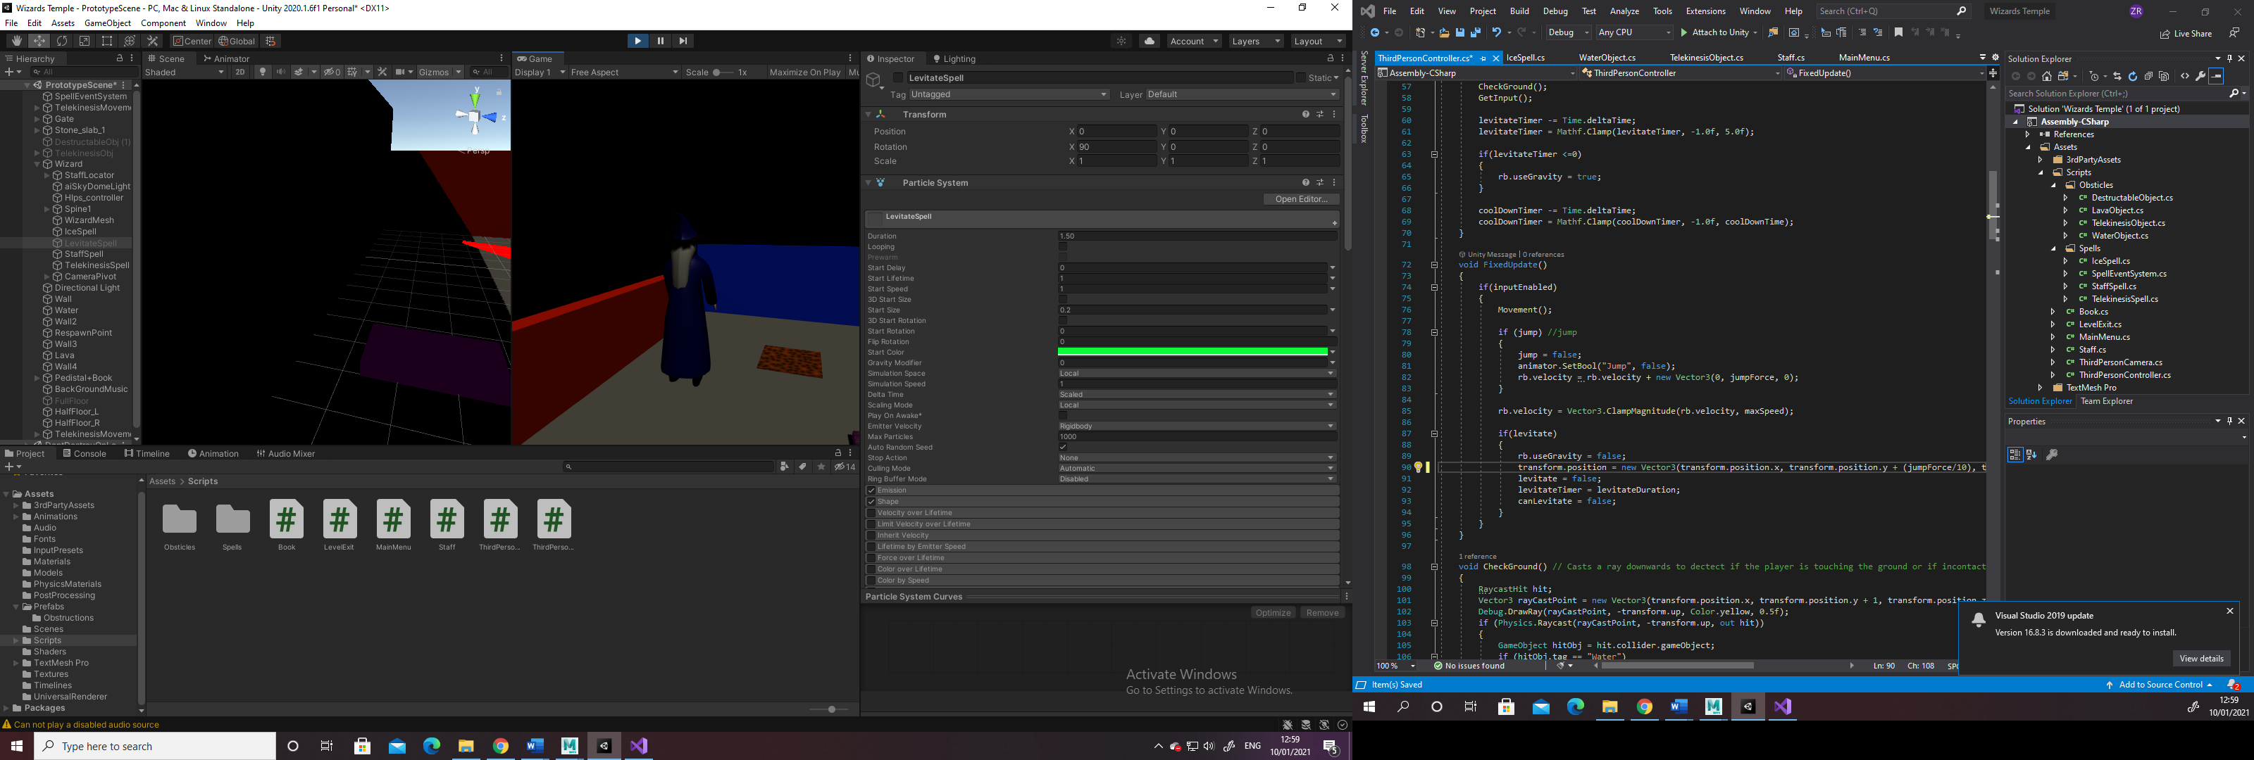

Fig. 7
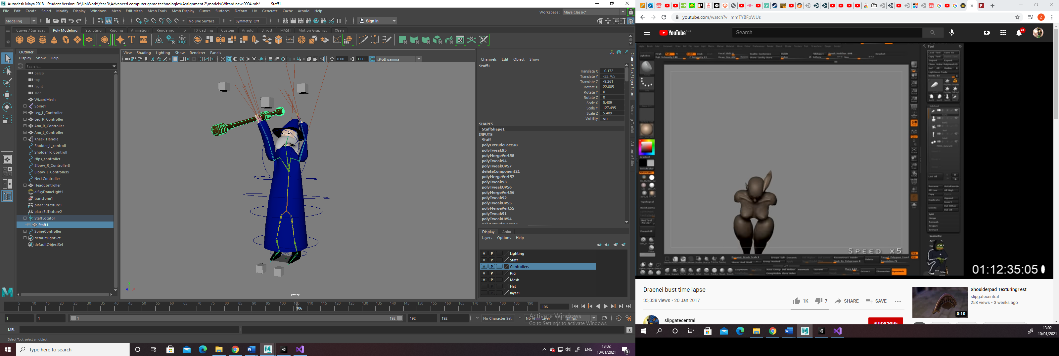

Fig. 8
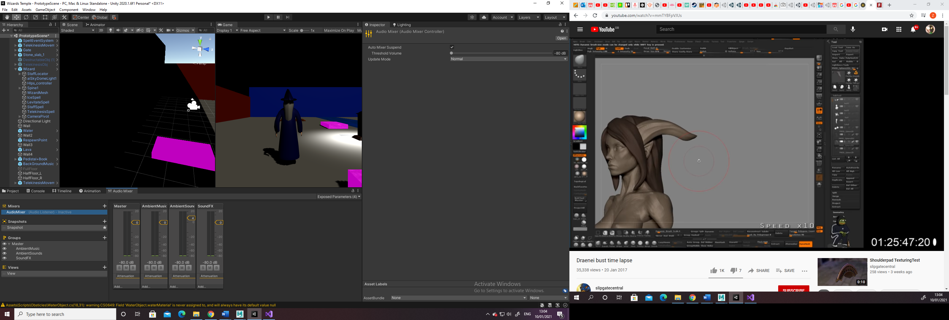

Fig. 9
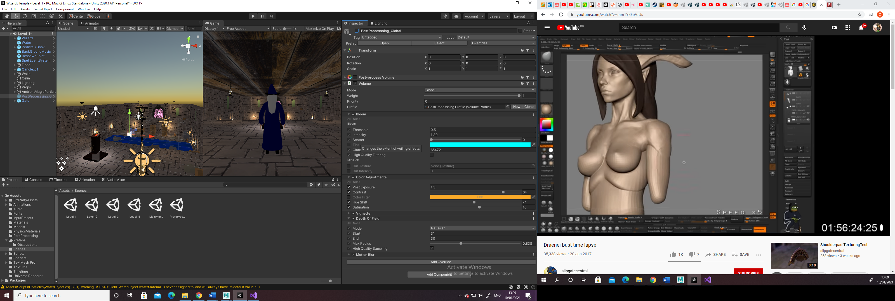

Fig. 10
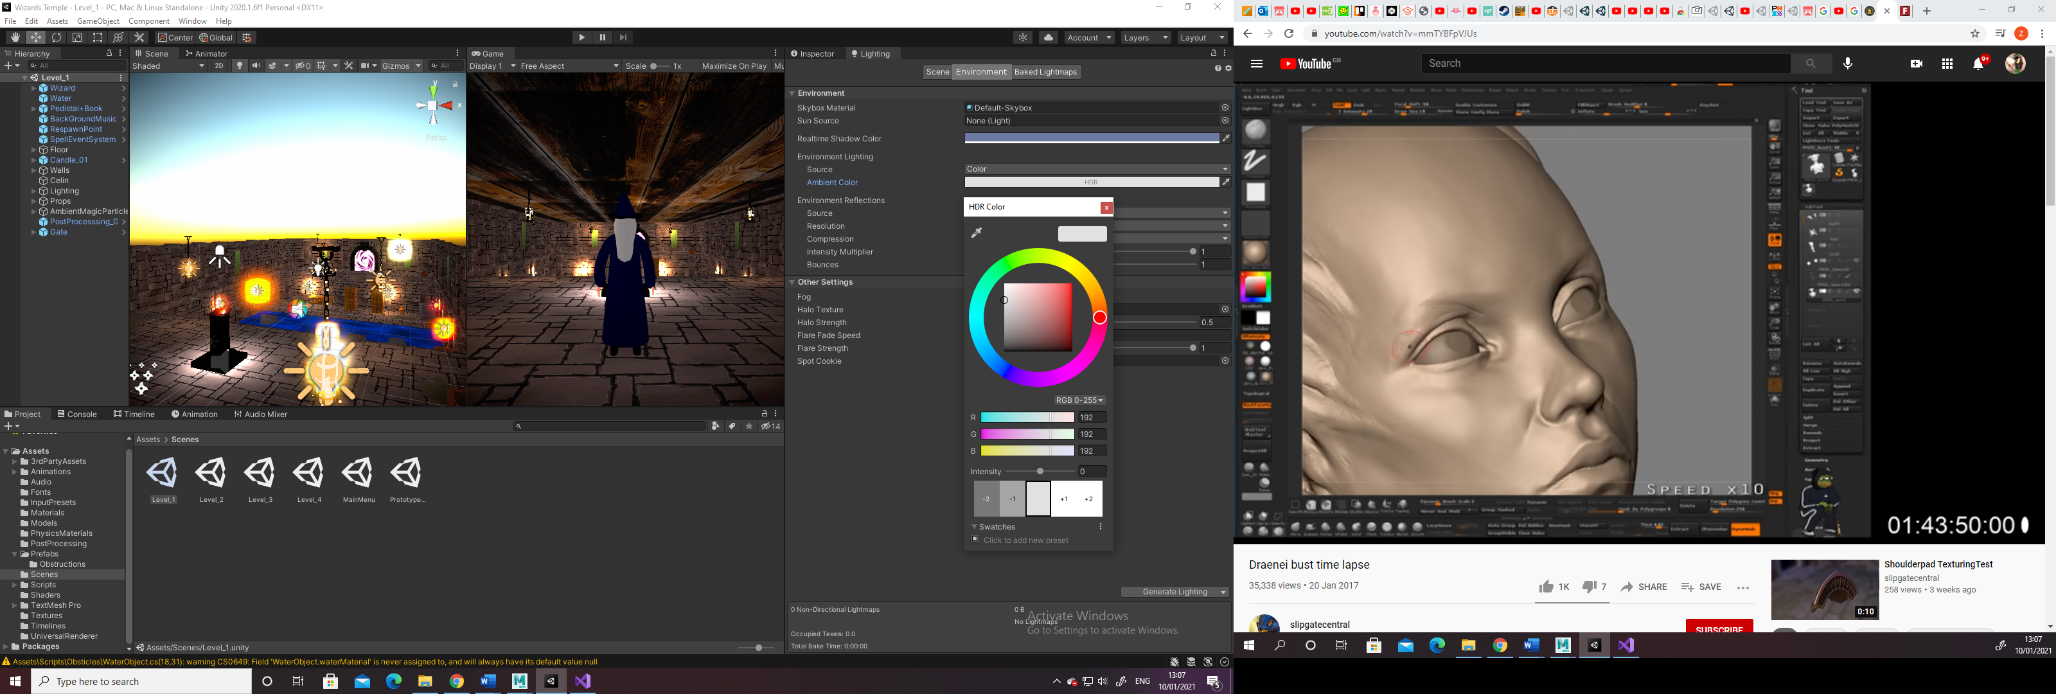

Fig. 11
